HRMS

酒店预订管理系统

逻辑设计图

学 院：南京大学软件学院

成 员：卢忆卿 李紫欣 刘钰 黄飘

完成日期：2016/10/9

目录

更新历史 3

一、概要功能设计 4

二、体系结构逻辑设计方案 5

三、进程图 5

四、部署图 6

五、最终开发包设计 7

六、服务器端及客户端开发包 9

# 更新历史

|  |  |  |  |
| --- | --- | --- | --- |
| 修改人员 | 修改日期 | 修改原因 | 版本号 |
| **全体成员** | **2016/10/7** | 草稿 | **V0.0.1** |
| **卢忆卿** | **2016/10/9** | 排版 | **V0.0.2** |

# 一、概要功能设计

|  |  |
| --- | --- |
| **功能** | **对应逻辑包** |
| **客户** | clientui,clientbl,clientdata  orderbl,orderdata  hotelinfo,hotelinfodata |
| **酒店工作人员** | hotelstaffui, hotelstaffbl, hotelstaffdata  orderbl,orderdata  hotelinfobl,hotelinfodata  strategybl,strategydata |
| **网站营销人员** | marketingui,marketingbl,marketingdata  clientbl,clientdata  orderbl,orderdata  strategybl,strategydata |
| **网站管理人员** | sitemanagerui,sitemanagerbl,sitemanagerdata  clientbl,clientdata  hotelstaffbl, hotelstaffdata  hotelinfobl, hotelinfodata  marketingbl,marketingdata |
| **订单** | orderui,orderbl,orderdata  clientbl,clientdata  hotelinfobl,hotelinfodata  marketingbl,marketingdata  strategybl, strategydata |
| **酒店信息** | hotelinfoui, hotelinfobl, hotelinfodata |
| **销售策略** | strategyui, strategybl, strategydata  hotelinfoui, hotelinfobl,hotelinfodata  clientui,clientbl,clientdata |

# 二、体系结构逻辑设计方案

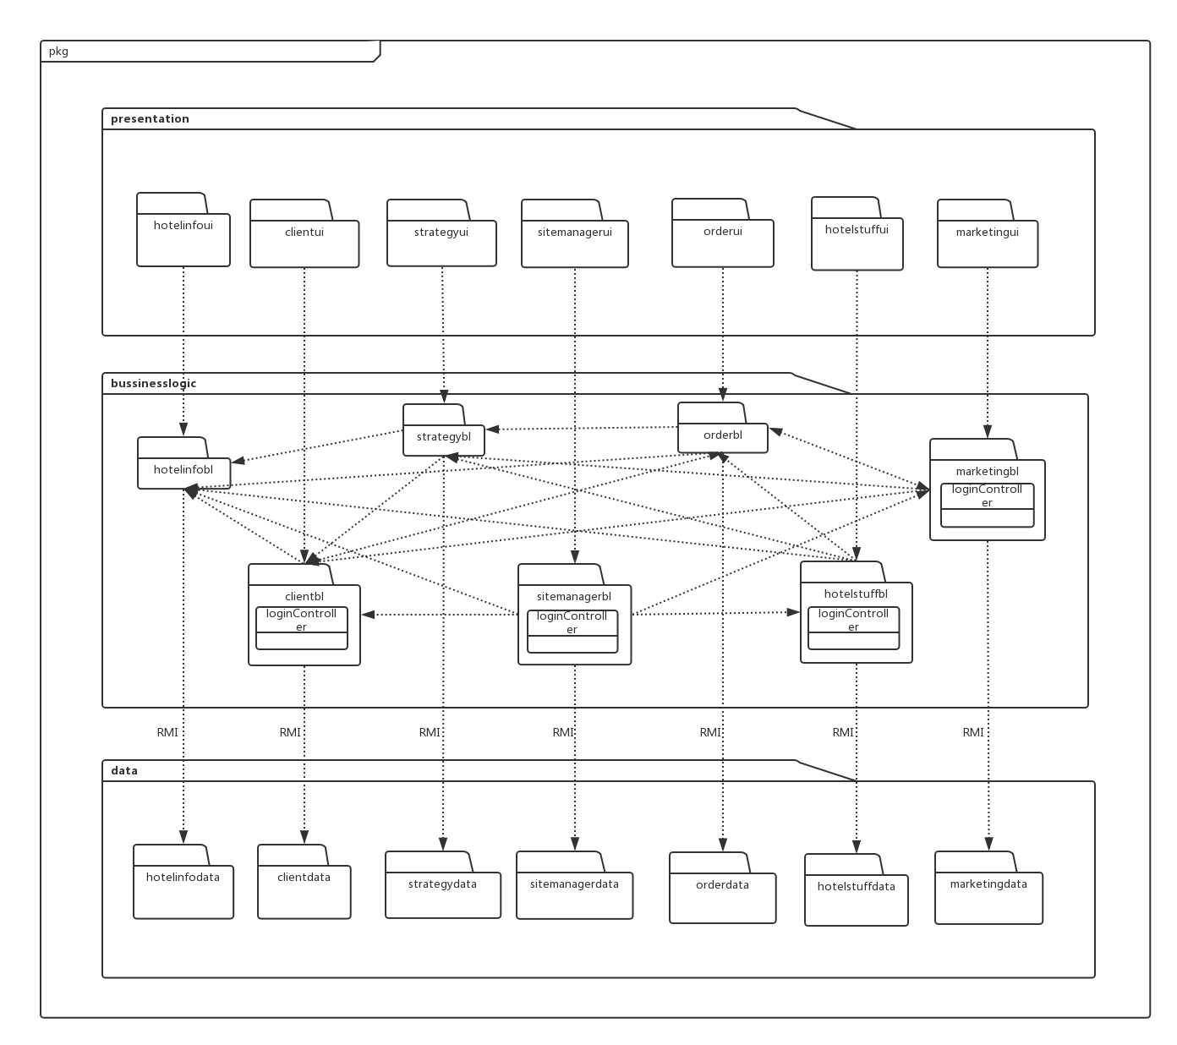

图2-1 体系结构逻辑设计方案

# 三、进程图

如图3-1，在酒店管理系统中，会有多个客户端进程和一个服务器端进程。客户端进程实在客户端机器上运行，服务器端进程是在服务器端机器上运行。

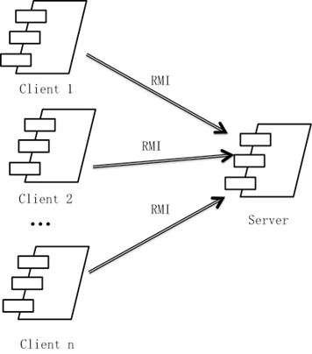 图3-1 进程图

# 四、部署图

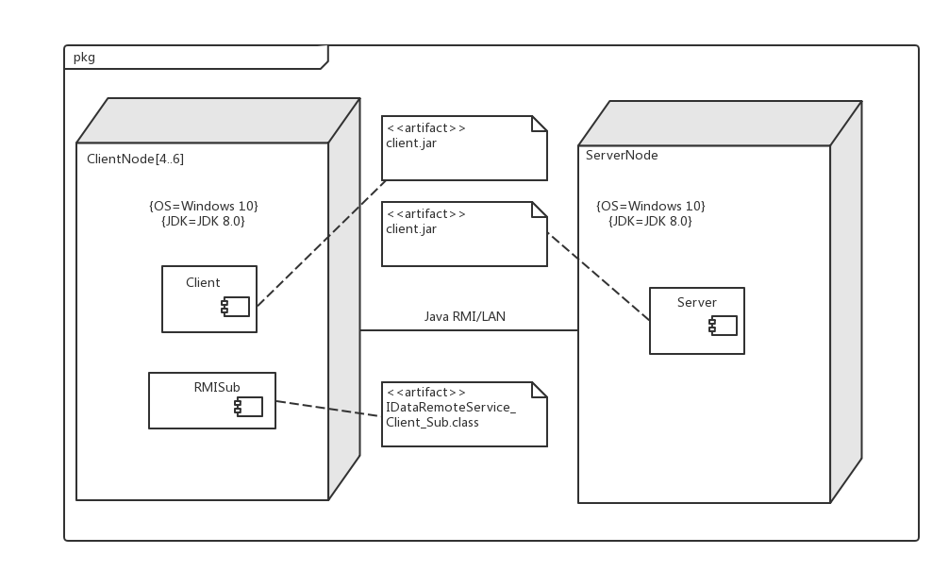

图4-1 部署图

# 五、最终开发包设计

|  |  |
| --- | --- |
| 开发（物理）包 | 依赖的其他开发包 |
| mainui | clientui,hotelstuffui,marketingui,sitemanagerui,orderui,strategyui,hotelinfoui, VO |
| loginui | loginblservice,界面类库包,VO |
| loginblservice |  |
| loginbl | loginblservice,PO,clientdataservice,hotelstaffdataservice,marketingdataservice, sitemanagerdataservice |
| intialblservice |  |
| initialbl | intialblservice,initialdataservice,PO,hotelinfobl,strategybl,orderbl |
| initialdataservice | Java RMI, PO |
| initialdata | Java RMI, PO, databaseutility |
| clientui | orderblservice,loginblservice,界面类库包,VO |
| clientblservice |  |
| clientbl | clientblservice,orderblservice,hotelInfoblservice |
| clientdataservice | Java RMI,PO |
| clientdata | PO, clientdataservice, databaseutility,orderdataservice |
| hotelstaffui | hotelstaffblservice,loginblservice,界面类库包, VO |
| hotelstaffblservice |  |
| hotelstaffbl | Hotelstaffblservice,hotelstaffdataservice, PO  strategybl,orderbl,hotelinfobl |
| hotelstaffdataservice | JavaRMI, PO |
| hotelstaffdata | databaseutility,po,JavaRMI |
| marketingui | marketingblservice,loginblservice界面类库包, VO |
| matketingblservice |  |
| marketingbl | marketingblservice,marketingdataservice,po,clientbl,orderbl,strategybl |
| marketingdataservice | Java RMI, PO |
| marketingdata | Java RMI,po,databaseutility |
| sitemanagerui | sitemanagerblservice,loginblservice,界面类库包包, VO |
| sitemanagerblservice |  |
| sitemanagerbl | sitemanagerblservice,sitemanagerdataservice,po,clientbl,hotelstaffbl,hotelinfobl,marketingbl |
| sitemanagerdataservice | Java RMI, PO |
| sitemanagerdata | Java RMI, PO, databaseutility |
| orderui | orderblservice,界面类库包, VO |
| orderblservice |  |
| orderbl | orderblservice,orderdataservice,PO,clientbl,hotelinfobl, marketingbl,strategybl |
| orderdataservice | Java RMI, PO |
| orderdata | Java RMI, PO, databaseutility |
| hotelinfoui | hotelinfoblservice,界面类库包, VO |
| hotelinfoblservice |  |
| hotelinfobl | hotelinfoblservice,hotelinfodataservice, PO |
| hotelinfodataservice | Java RMI, PO |
| hotelinfodata | databaseutility,po,Java RMI |
| strategyui | strategyblservice, 界面类库包, VO |
| strategyblservice |  |
| strategybl | strategyblservice,strategydataservice,po,hotelinfobl,clientbl |
| strategydataservice | Java RMI, PO |
| strategydata | Java RMI,po,databaseutility |
| logblservice |  |
| logbl | logblservice,logdataservice,po |
| logdataservice | Java RMI, PO |
| logdata | Java RMI,po,databaseutility |
| vo |  |
| po |  |
| Utilitybl |  |
| 界面类库包 |  |
| Java RMI |  |
| databaseutility | JDBC |

# 六、服务器端及客户端开发包

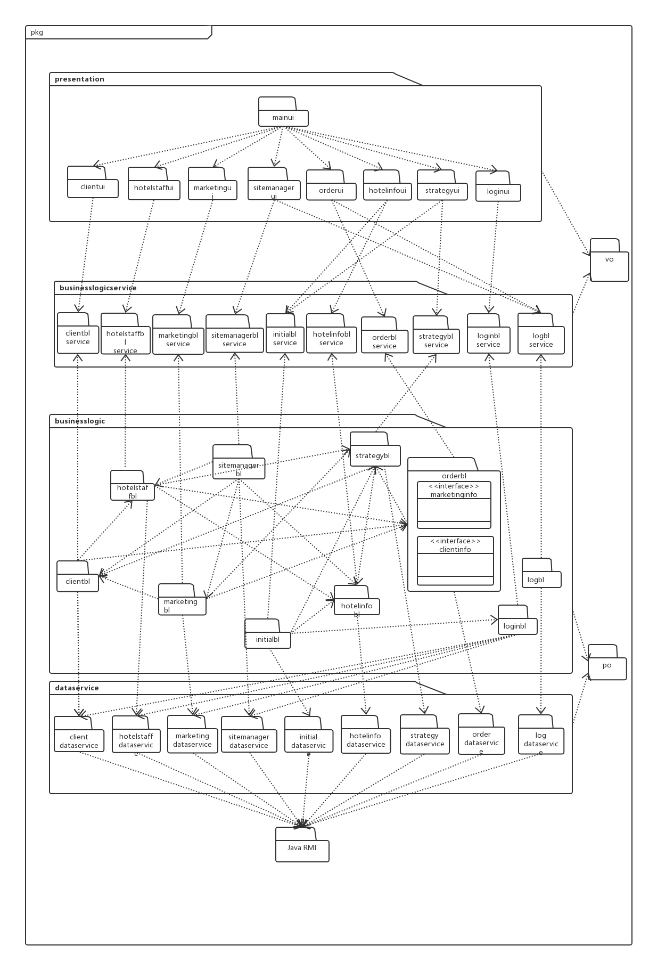

图6-1客户端开发包图

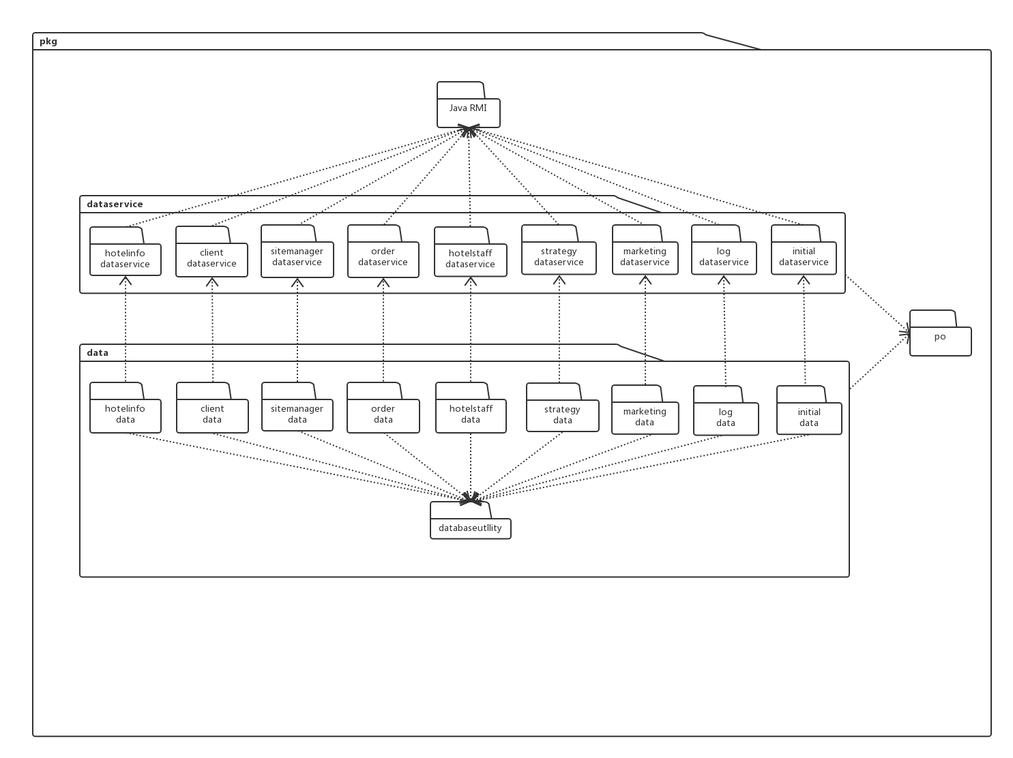

图6-2 服务器端开发包图